Lesson 6 Reteach

Analyze Data Distributions

The distribution of data can be described by its center, spread (variation), and overall shape. If data on a line plot are symmetric, then the left side looks like the right side. Another way to describe the shape of the distribution is to identify peaks, clusters, gaps, and outliers.

Example
BOOKS The graph shows the number of books students read during the summer. Identify any symmetry, clusters, gaps, peaks, or outliers in the distribution.
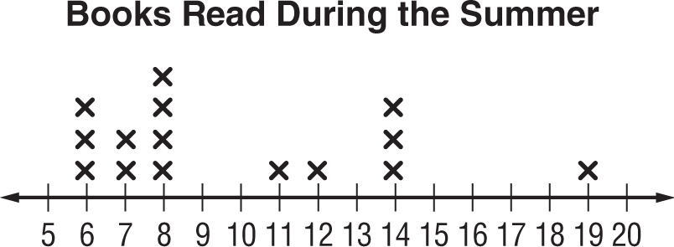
The distribution is non-symmetric because the left side does not look like the right side of the graph.
There is a cluster from 6 to 8 with a peak at 8.
There are two gaps. One gap is between 8 and 11 and another gap between 14 and 19.
There is an outlier at 19.

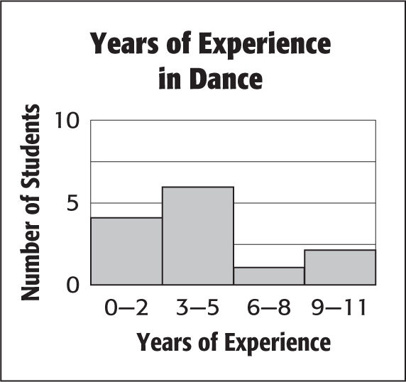
Exercises

1. DANCE The number of years of experience in dance for various students is shown in the graph.

a. Describe the shape of the distribution.

b. Identify any clusters, gaps, peaks, or outliers.

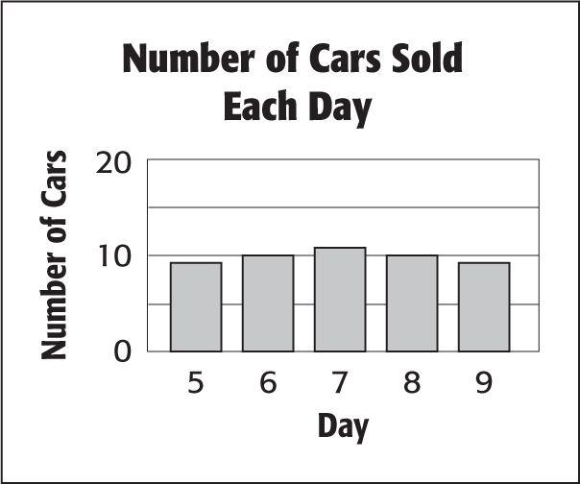
2. CARS The number of cars sold each day is shown in the graph.

a. Describe the shape of the distribution.

b. Identify any clusters, gaps, peaks, or outliers.

